Project Development Phase
Performance Test

Date | 10 February 2025
Team ID | PNT2022TMIDxxxxxx
Project Name | Import Data using Transform Maps (Spreadsheet)
Maximum Marks

Model Performance Testing:
Project team shall fill the following information in model performance testing template.
S.No. | Parameter | Screenshot / Values
 | Data Rendered | Spreadsheet with 5 student records (Student ID, Student Name, Department, Email, Year) loaded into ServiceNow.  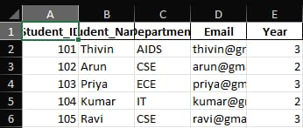
 | Data Preprocessing | Custom table Student Information created with typed columns (Integer / String) and the Transform Map maps each source field to its target field. Transform result: 5 inserts, 0 errors.  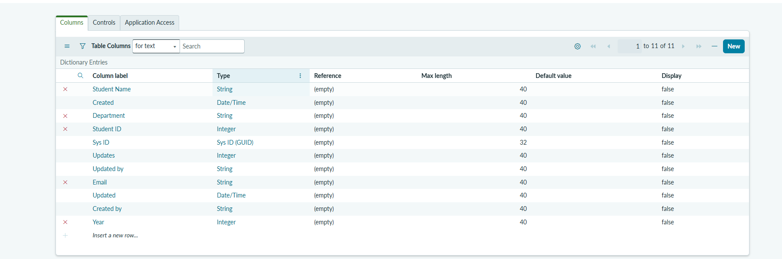
3. | Utilization of Filters | Report condition "All" (no records excluded); report is grouped by Email.  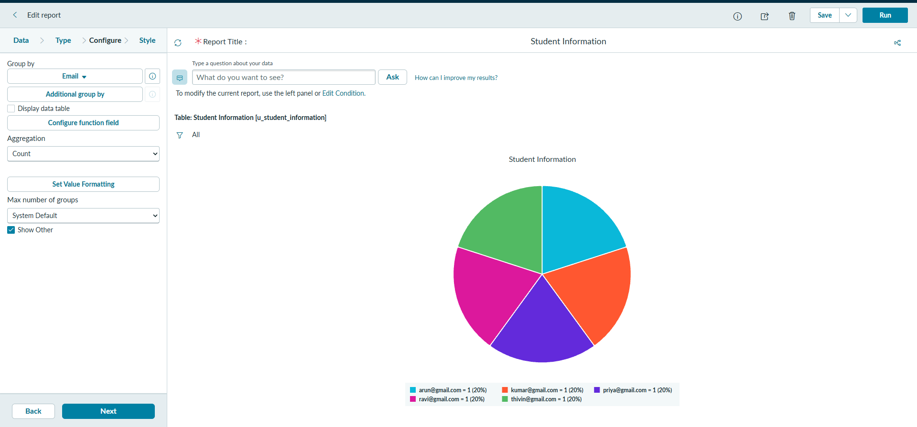
4. | Calculation fields Used | No custom formula needed. Aggregation used: Count of records grouped by Email.
5. | Dashboard design | No of Visualizations / Graphs - 2 (single score showing 5 and a line chart of records by date).  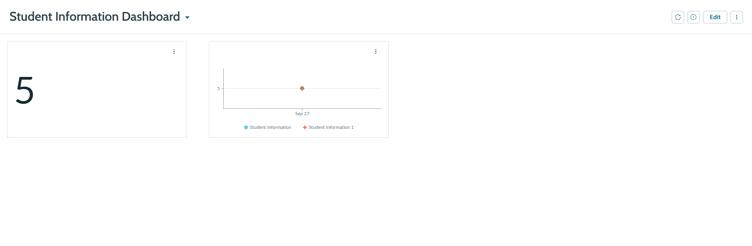
6 | Story Design | No of Visualizations / Graphs - 1 (pie chart "Student Information", 5 slices of 20%).

